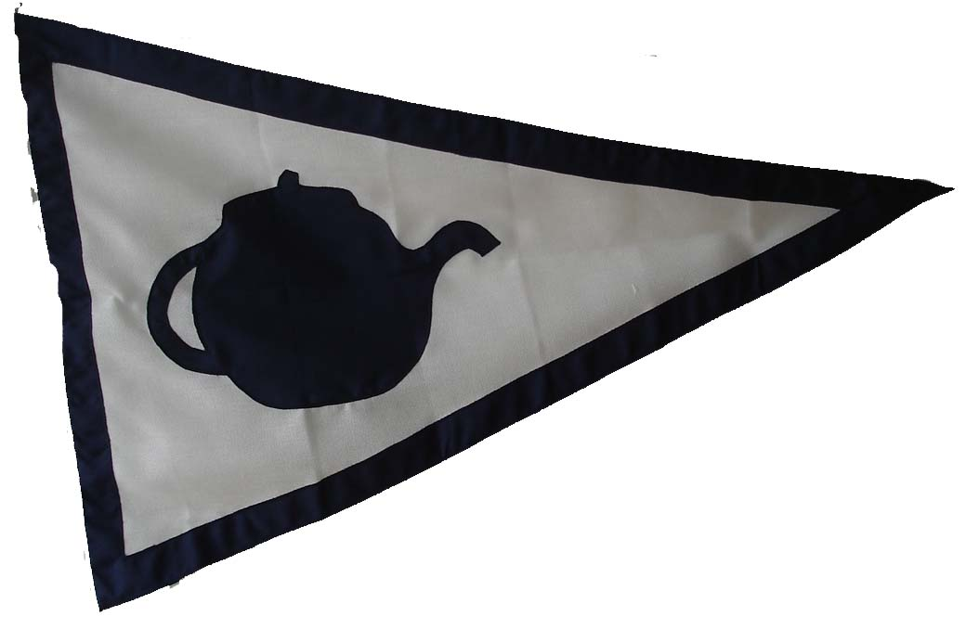
Buchanan Owners Association
www.buchananownersassociation.com
0870 300 1066
Application Form info@buchananownersassociation.com

Name of Vessel ………………………………………………….

Name of Owner ………………………………………………….

Address ………………………………………………….

………………………………………………….

………………………………………………….

Tel # ………………………… Mobile # ……………………….

Email address …………………………………

Design # / Name of Design …………………………………………………………

Year built ………………………. Built By ………………………………………….

LOA ………….. LWL …………… Beam …………….. Draft ………………..

Any Comments ……………………………………………………………………….

…………………………………………………………………………………………

…………………………………………………………………………………………

………………………………………………………………………………………….

………………………………………………………………………………………….

…………………………………………………………………………………………

…………………………………………………………………………………………
Please send membership fee of £50 with application form to;
Buchanan Owners Association c/o Active, 4th Floor, 1-5 Clerkenwell Rd., London
EC1M 5PA. Please if at all possible send history of vessel and photographs by email. If photographs are not submitted electronically they will be returned by post with club burgee

